®
®
Spyder BACnet
Programmable Controllers
SPECIFICATION DATA
provides flexible, universal inputs for external sensors,
digital inputs, and a combination of analog outputs and
digital outputs.
The photo shown is the PVB6436AS, which includes the
Series 60 floating actuator.
FEATURES
•
•
Uses BACnet MS/TP network communication.
EIA-485 communications network. Capable of baud
rates between 9.6 and 115.2 kbits/s.
•
Capable of stand-alone operation, but can also use
BACnet MS/TP network communications.
•
•
Sylk™ bus for use with Sylk-enabled sensors.
APPLICATION
Support for up to 40 controllers per BACnet MS/TP
segment (under 30 is recommended).
The PUB and PVB controllers are part of the Spyder family.
The nine controllers are BACnet MS/TP network devices
designed to control HVAC equipment. These controllers
provide many options and advanced system features that
allow state-of-the-art commercial building control. Each
controller is programmable and configurable using the
NIAGARA FRAMEWORK® software.
•
•
Field configurable and programmable for control,
input, and output functions using the NIAGARA
FRAMEWORK® software.
Function Block engine, which allows the application
designer to program the controller to perform a wide
variety of HVAC applications.
The Spyder BACnet controllers require the Spyder BACnet
Programmable Feature to be licensed in the WEBpro
workbench tool and the WEBS AX JACE Controller for
programming and downloading. The Spyder BACnet Models
are also available as Individually Licensed Controllers (ILC).
The ILC versions are identical in design and capability in
every detail except for the licensing. The Individual
Licensing of the Spyder ILCs (the License is built in) allows
them to be programmed and downloaded with any brand of
the Niagara Workbench or JACE controller. The Spyder ILCs
are identified with a suffix on the Part Number of -ILC.
Example: PUB6438S-ILC follows all the same Installation
Instructions information as the PUB6438S.
•
•
Built-in Zone Control functions include a remote wall
module interface and a scheduler.
Pressure-independent or pressure-dependent single
or dual duct Variable Air Volume (VAV) control as well
as Unitary equipment control.
•
Microbridge air flow sensor with dual integral restric-
tor design (PVB0000AS, PVB4022AS, PVB4024NS,
PVB6436AS, and PVB6438NS).
•
•
Easy user access to air flow sensor inputs.
Actuator (PVB0000AS, PVB4022AS, and
PVB6436AS) mounts directly onto VAV box damper
shaft and has up to 44 lb-in. (5 Nm) torque, 90-
degree stroke, and 90 second timing at 60 Hz.
The controllers are for use in VAV (Variable Air Volume),
Unitary, and advanced HVAC control applications. Each
controller contains a host microcontroller to run the main
HVAC application and a second microcontroller for
BACnet MS/TP network communications. Each controller
•
•
All wiring connections are made to removable
terminal blocks to simplify controller installation and
replacement.
Both controller housing and actuator are UL plenum
rated.
63-1328-08
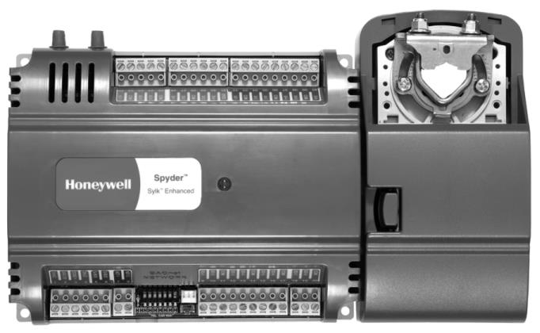

SPYDER® BACNET® PROGRAMMABLE CONTROLLERS
DESCRIPTION
The programmable VAV/Unitary controllers are available in three models, as described in Table 1.
Table 1. Controller Configurations.
UI
Programmable (Universal (Digital (Analog (Digital
Type Input) Input) Output) Output)
DI
AO
DO
Velocity Pressure
Sensor
(Microbridge)
Controller
Model
Series 60
Floating Actuator
PUB1012S
Unitary
₁a
₄a
0
1
2
4
8
NO
NO
PUB4024S
Unitary
0
2
NO
NO
NO
PUB6438S
PUB6438SR
PVB0000AS
PVB4022AS
Unitary
Unitary
VAV
6
4
4
0
0
3
3
0
2
NO
6
8 Relays NO
NO
0
0
2
YES
YES
YES
YES
VAV
₄a
PVB4024NS
VAV
₄a
0
2
4
YES
NO
PVB6436AS
PVB6438NS
VAV
VAV
6
6
4
4
3
3
6
8
YES
YES
YES
NO
a
One Universal Input (UI-1*) is user selectable as a fast digital pulse meter
SPECIFICATIONS
Electrical
Rated Voltage: 20-30 Vac; 50/60 Hz
Power Consumption:
100 VA for controller and all connected loads (including
the actuator on model PVB6436AS)
Controller only Load: 5 VA maximum; models PVB6438NS,
PUB6438S, and PUB6438SR
Controller and Actuator Load: 9 VA maximum; model
PVB6436AS
External Sensors Power Output: 20 Vdc ±10% @ 75 mA
maximum
Each controller is programmable because the user
chooses which function blocks to use and how to connect
them. It is configurable because each Function Block has
user-defined behavior.
The PVB6436AS and PVB6438NS models are Variable Air
Volume (VAV) controllers, and the PUB6438S and
PUB6438SR models are Unitary controllers.
VAV Equipment Control
(PVB0000AS, PVB4022AS,
PVB4024NS, PVB6436AS, and
PVB6438NS)
The VAV controllers provide pressure-independent air flow
control and pressure-dependent damper control. VAV
systems generally provide cool air only to zones. However,
each controller has additional programmable inputs and
outputs that may be used to control devices, such as a fan
or VAV box reheat coils. Heaters can be staged electric or
modulating hot water. Supply and exhaust pressurization
control are provided on a zone basis.
Environmental
VAV Operating & Storage Temperature Ambient Rating
(models PVB0000AS, PVB4022AS, PVB4024NS,
PVB6436AS, and PVB6438NS):
Minimum 32° F (0° C); Maximum 122° F (50° C)
Unitary Operating & Storage Temperature Ambient Rating
(models PUB1012S, PUB4024S, PUB6438S, and
PUB6438SR):
Minimum -40° F (-40° C); Maximum 150° F (65.5° C)
Relative Humidity: 5% to 95% non-condensing
Unitary Equipment Control
(PUB1012S, PUB4024S, PUB6438S, Dimensions (H/W/D)
and PUB6438SR)
See Fig. 1 to Fig. 4 beginning on page 6 for dimensioned
drawings.
PUB1012S, PUB4024S, and PVB4024NS:6.25 x 4.81 x
2.26 in. (15.92 x 12.20 x 5.74 cm)
PVB0000AS, PVB4022AS (including Actuator):
6.60 x 8.28 x 2.26 in. (16.70 x 21.10 x 5.74 cm)
PVB6436AS (including Actuator): 6.27 x 10.316 x 2.26 in.
(15.92 x 26.20 x 5.74 cm)
Unitary equipment includes natural convection units,
radiant panels, unit heaters, unit ventilators, fan coil units,
and heat pumps. Unitary equipment does not require a
central fan. Depending on design, unitary equipment may
perform one or all of the functions of HVAC—ventilation,
filtration, heating, cooling, humidification and
distribution. Unitary equipment frequently requires a
distribution system for steam or hot and or chilled water.
PVB6438NS: 5.76 x 6.85 x 2.26 in. (14.62 x 17.40 x 5.74 cm)
PUB6438S, PUB6438SR: 5.45 x 6.85 x 2.26 in. (13.84 x
17.40 x 5.74 cm)
63-1328—08
2


